HEALTH CARE
- Regular farrier care (hoof trimming and shoeing) runs from $20 for basic trimming to over $100 for shoeing all around and more for special care. The average horse needs farrier care every six to eight weeks.
- Regular worming – every six to eight weeks. Wormer runs between $8 - $12 per tube
- Regular veterinary care – seasonal vaccinations. Some can be administered by the horse owner, others require veterinary certification. The vet calls start at $35, and the shots vary in price, but plan on spending at least $75 per visit, 2 visits per year.
- Annual dental check ups – can be administered by your veterinarian during one of his seasonal visits, or by an equine dentist, approximately $35 per visit, average of 2 visits per year.
- Emergency veterinary care – can run from stitching a wound to major surgery at a veterinary hospital - $100 - $10,000 and up.
- Incidental health care supplies – thermometer, antiseptic ointment, surgical scrub, liniment – a pre-made first aid kit runs about $75.
- Your own daily labor to make sure that your horse is happy, comfortable and healthy.

Basic Equipment
- Halter and lead rope – even if you don’t ride or drive your horse, you will need a halter and lead rope to control your horse, $15 - $75 (new).

- Bridle or harness - $50 - $500 (new) and may or may not include reins and a bit.
- Saddle for riding or cart for driving, $400 - $2000 (new, for the saddle), $1000 on up for the cart.
- Saddle pads, martingales, breast plates, girths, wraps, boots, blankets, coolers, sheets, buckets (for bathing), saddle soap (leather goods last longer when cared for). You don’t have to break the bank, but it is easy to do.

These are approximate prices

Buy in haste, repent in leisure

- Have you ever purchased a horse before? Do you know how to purchase a horse? If this is your first horse, are you looking for a deal, a dream, or a safe, healthy horse who will teach you how to care for a horse? If you’re looking for a deal, there is no such thing as a free horse. If you’re looking for your dream horse, save that for when you have more experience in horse ownership. Find a trusted trainer or horse professional to help find an appropriate horse. Although it may cost more initially to purchase a horse through a professional, the cost is frequently much less than correcting a mistake of buying the wrong horse.
- To avoid heartache, a pre-purchase exam is strongly recommended. A pre-purchase exam can help make sure the horse you want is sound and healthy.
- What will you do if your children outgrow it or lose interest, or if the horse becomes unusable because of injury or illness?

Options to Ownership
- Consider riding lessons – you get the fun part without the drudgery.
- Consider leasing – you get to try the horse “ownership”, but if it doesn’t work, you can return the horse to the owner, and walk away without the guilt.
- Consider volunteering – more hands-on work, without the daily responsibility.
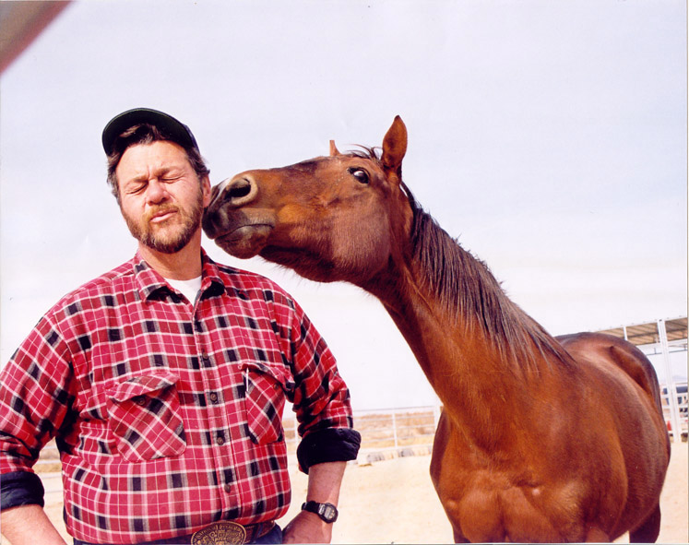
- Consider joining your local 4-H Horse and Pony program, or the United States Pony Club.

Jack Auchterlonie

Memorial Equine

Sanctuary

J.A.M.E.S.
Twentynine Palms, CA. 92277
(760) 362-1357

“a safe house for horses”

JAMES is a 501(c)3 nonprofit

Public Benefit Corporation

Horses provide numerous, positive benefits. Horses......
- Are wonderful companions;
- Can become a lifelong hobby;
- Can help create a wholesome environment for children & adults;
- Can help enhance self-esteem;
- Provide an opportunity to develop enduring friendships;
- Provide a method for teaching and learning important life skills, including responsibility;
- Help develop a compassionate
approach to life;
- Are an excellent form of exercise & recreation.

and think!

Horse ownership is a huge responsibility and commitment. Before you acquire that adorable pony or wonderful horse, consider that horses and ponies.......

- Require an ongoing financial commitment. The least expensive part of horse ownership is usually the purchase price.
- Require a great deal of time and physical labor just in daily care;
- Require a great deal of specific knowledge for proper care;
- Can live a very long life – sometimes up to 40 years;
- Usually prefer the company of other horses over people;
- Need food, water, stall cleaning (if stall kept), and looking after daily, 365 days a year – NO EXCEPTIONS;
- Can cause accidents without even trying;
- Need a lot of exercise.

Decisions to make if you want to own a horse.....

- Will you keep it at home or board it someplace else?
- If you board it at home, do you have a safe place to keep the horse? Who will be responsible for maintenance (fence repair, pasture management, etc.)? Does the zoning in your area allow horses?
- If you plan to board it at home, are you aware that you will be responsible for that horse 365 days a year? The weather, your health and your vacation schedule do not mean anything to your horse! Who will be responsible for daily care? Can you find backup help for your horse when you go away?
- Have you considered how and what you will feed it? (No two horses have the same nutritional requirements, and the grass in your “pasture” may not be suitable to the horse you have in your barn.)
- If you board it someplace else, will you be responsible for caring for it daily, or will someone else?
- Do you want to purchase the horse to teach your children responsibility? Horses cannot teach responsibility to children, they can only help parents teach responsibility. Responsibility for a child’s horse always falls to the parents.

REALITY CHECK: DOLLARS & CENTS

BOARD
- Self-care Field Board in California starts at around $60 per month – for just the space. The horse owner must purchase everything else and provide the labor.
- Full-care field board starts at about $110 per month.
- Self-care stall board starts at about $65 per month. The owner of the horse is responsible for feeding twice a day and for cleaning the stall on a daily basis.
- Full care stall board can range from $175 - $600 per month.

FEED
- GRAIN: Begins @$8 per 50# bag (horses may need anything from nothing or a handful of grain to over 10# per day.)
- Hay: Depending on the type and weight of the bale and the time of the year, $6.50 per bale on up. Horses will eat from 1 to 1 ½ bales per week depending on the type of hay and the bale weight.

HOME SWEET HOME
- Safe fencing – can start at $4 per foot (how big is your back yard?) Fencing is in constant need of attention. Barbed-wire should never be used around horses, it is an accident waiting to happen.
- Shelter – Barn, run-in shed, stalls, loafing shed, or anything that allows the horse to escape from extreme weather conditions.
- Bedding (if stall kept) – Shavings run about $6 per 50# bag, straw runs about $4 per bale. Bedding needs to be changed daily.
- Basic Supplies – rakes, shovels, muck buckets or wheelbarrow, water and feed buckets, hoses, grooming equipment to see your horse’s physical comfort, etc. (and nothing lasts forever).
- Places to store feed – grains need to be protected from mold and rodents.

